**College Planner Application**

**COSC 412**

**Fall 2020**

**Katherine Borowy**

**Preface**

The purpose of this project is to create a cross-platform product that allows college students to organize their class tasks and job opportunities and goals. This application will be able to import schedules for school and work as well as assignment due date and information. The app will also allow students to create goals and deadlines for job-hunting, and will provide job/internship suggestions based on the student’s major. I believe this is an important application, as many students admit that they are not organized. This application will organize all career essentials for a college student into one site.

**Table of Contents**

1. Introduction

1.1 Overview

1.2 Deliverables

1.3 Evolution of SPMP

1.4 References

1.5 Definitions and Acronyms

2. Project Organization

2.1 Process Model

2.2 Organizational Structure

2.3 Organizational Interface

2.4 Project Responsibilities

3. Managerial Process

3.1 Management Objectives and Priorities

3.2 Assumptions, Dependencies and Constraints

3.3 Risk Management

3.4 Monitoring and Controlling Mechanisms

4. Technical Process

4.1 Methods, Tools, and Techniques

4.2 Software Documentation

4.3 Project Support Functions

5. Work Elements, Schedule, Budget

5.1 Work Breakdown Structure

5.2 Schedule

5.3 Budget

Revision Sheet

Introduction

1.1 Overview

1.2 Deliverables

* Individual Project Meeting October ?

1.3 Evolution of SPMP

* SPMP will be updated throughout the semester when necessary

1.4 References

* TO BE ANNOUNCED

1.5 Definitions and Acronyms

* TO BE ANNOUNCED

Project Organization

2. Project Organization

2.1 Process Model: Waterfall Process

This model makes the most sense for a semester project

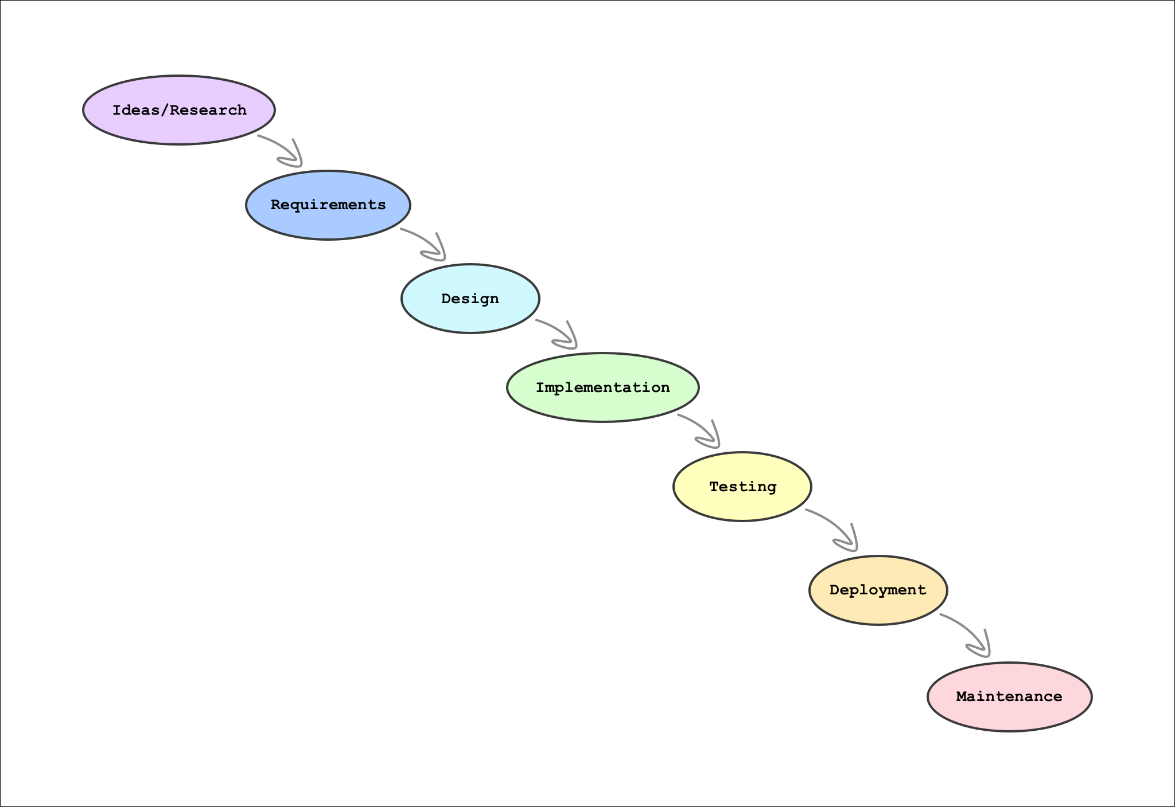

2.2 Organizational Structure

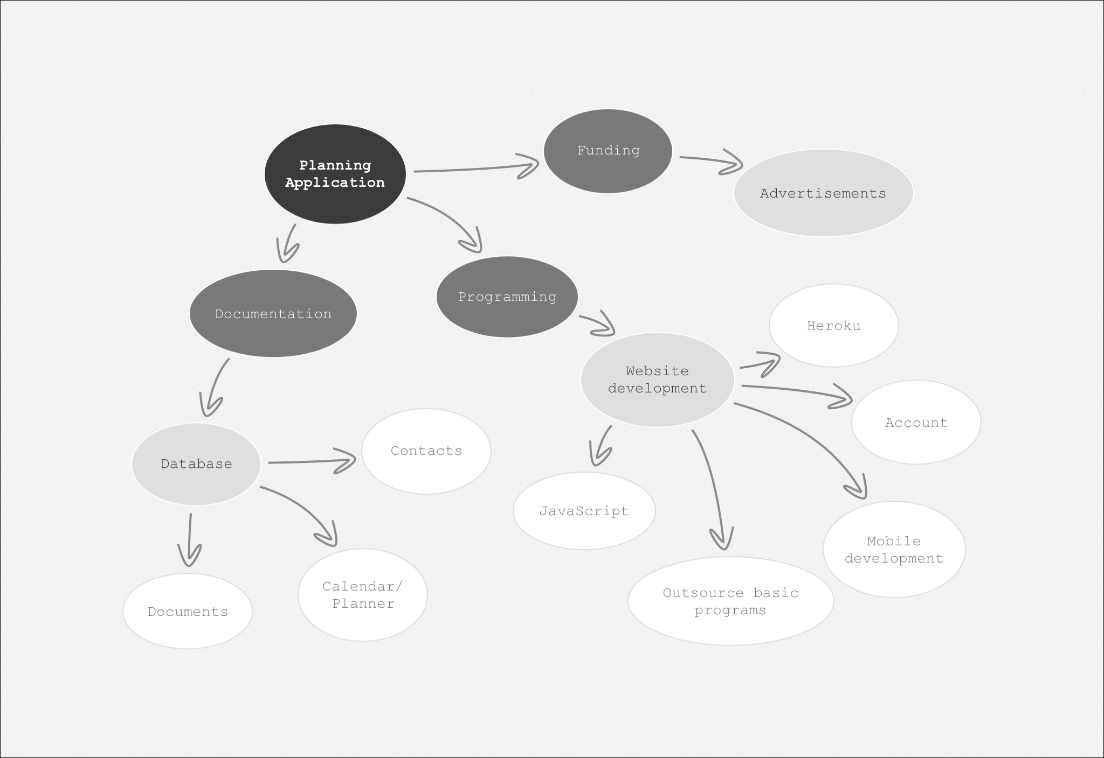

Managerial Process

3.1 Management Objectives and Priorities

* Since I have no client, I will be able to work on my own time. I will have meetings with my professor should I have any questions or concerns.

3.2 Assumptions, Dependencies and Constraints

* Assumptions/Dependencies
  + As a student, I am hoping to Heroku for free, as I currently have no plans to move forward with the project after this semester.
  + I will also be seeking guidance from my professor, as well as receiving advice from family members.
* Constraints
  + Time: I have until the end of November to finish a working prototype.
  + Money: As I stated before, I will use Heroku to host the website, because it is free for students.

3.3 Risk Management

* If Heroku no longer provides the free account, I will pay hosting fees until the end of the semester
* I will be using GitHub to save all my past iterations of the project incase of any accidents or issues.

3.4 Monitoring and Controlling Mechanisms

* The schedule I have created will keep me on track to complete the application to the best of my abilities.

Technical Process

4.1 Methods, Tools, and Techniques:

* Languages: HTML, CSS, Javascript
* Text Editor: VScode
* Database:
* Version Control: Github
* Web hosting: Heroku, Github Pages
* Object Oriented Programming: Classes, Inheritance, Encapsulation

4.2 Software Documentation

* Documentation exists to provide product functionality, combine project - related information and allow space to talk about any questions or concerns between stakeholders and developers.
* Documentation plan:
  + From the start to finish, the documentation goes over different aspects of the projects such as: high level requirements, test plans, test documentation, system documentation, installation guides, user manual and the final report. Below, we will expand over each part of the plan.
  + High level requirement:
    - Describes what the system should do and how it should do it.
  + Test plan:
    - How to test and what to test, making sure that the website functions properly.
  + Test documentation:
    - Documentation of the testing itself.
  + System documentation
    - Class diagrams, Code comments.
  + User manual
    - How to navigate and use it.
  + Final report:
    - Summary and conclusion.

4.3 Project Support Functions

* Testing:
  + Test plans
  + Test procedures
  + Unit testing
  + Integration testing
  + Alpha testing
  + Beta testing
  + Acceptance(final test)
* Configuration control
  + Program code changes
  + Requirements and design changes
* Quality assurance:
  + Make sure this works at the end
  + Bug testing

Work Elements, Schedule, Budget

5.1 Work Breakdown Structure

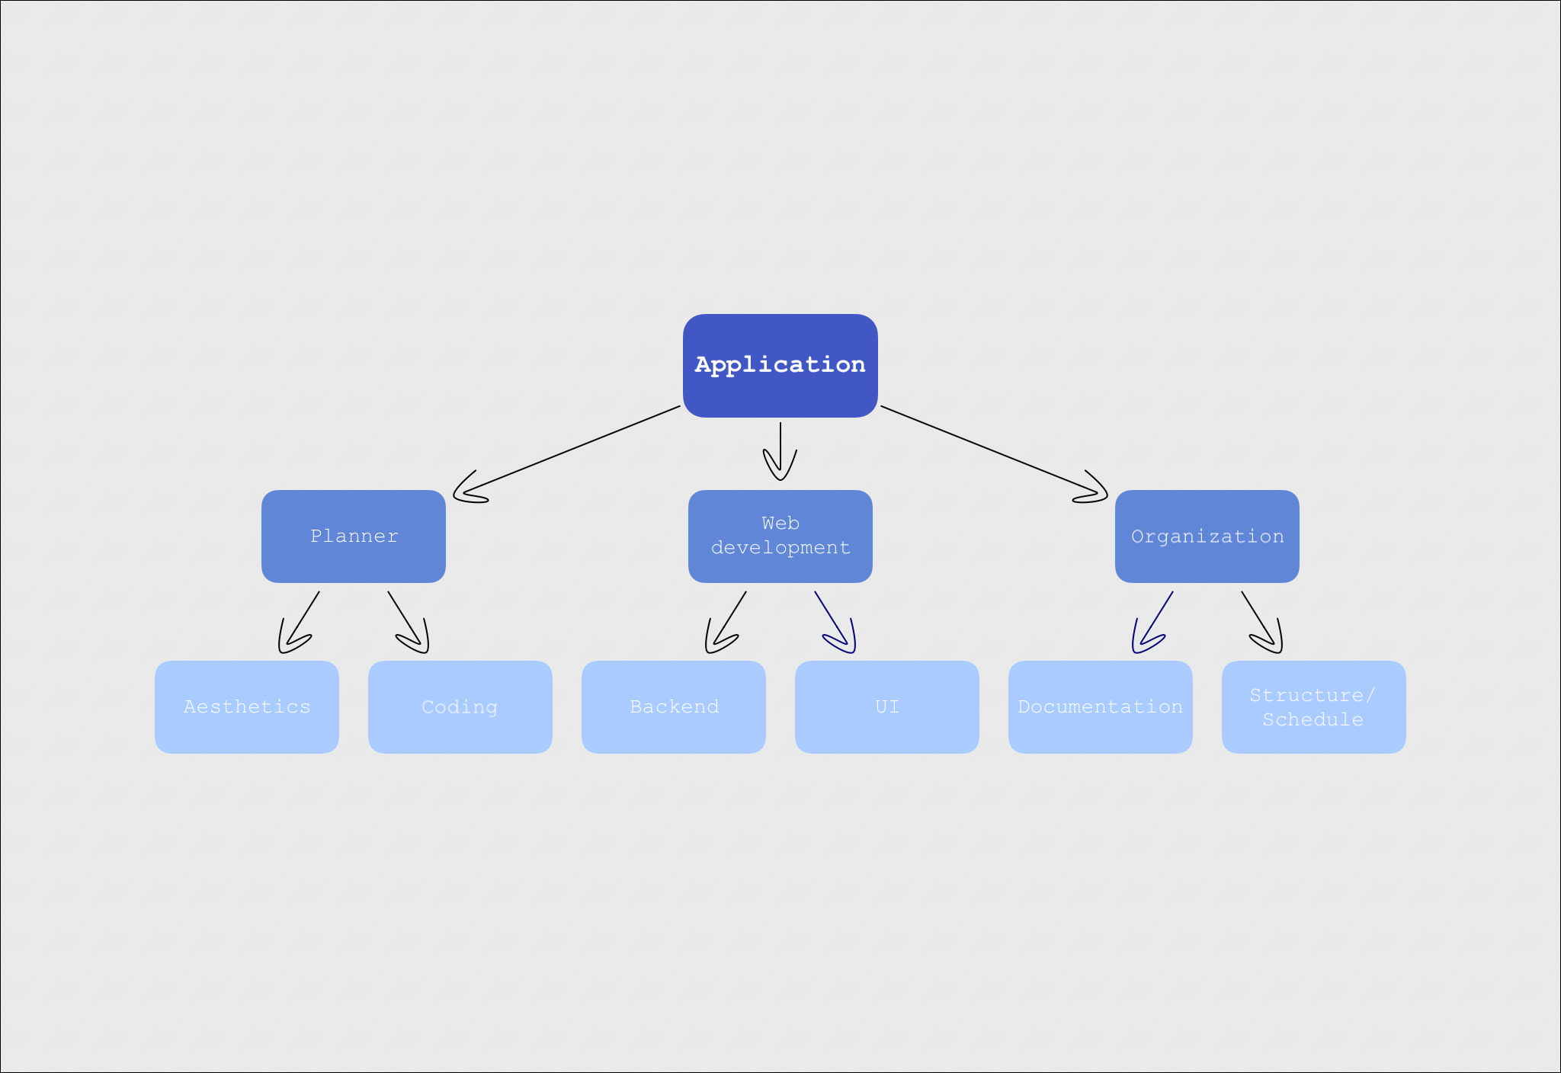

5.2 Schedule/Gantt Chart

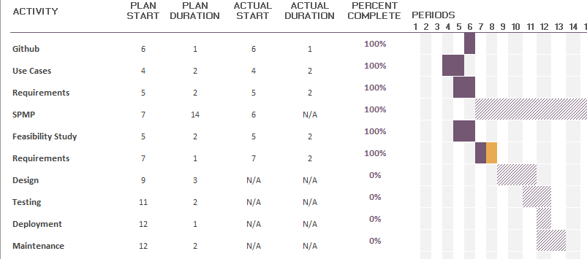

5.3 Budget

* Since I am a student, I would like to keep the cost of this project inexpensive. I am using developing tools that are free, and a relatively inexpensive hosting site,